Key cloak realms creation – users creation

Create Realm

Create Client

Provide a name

Enable Client Authentication and service account roles.

Save

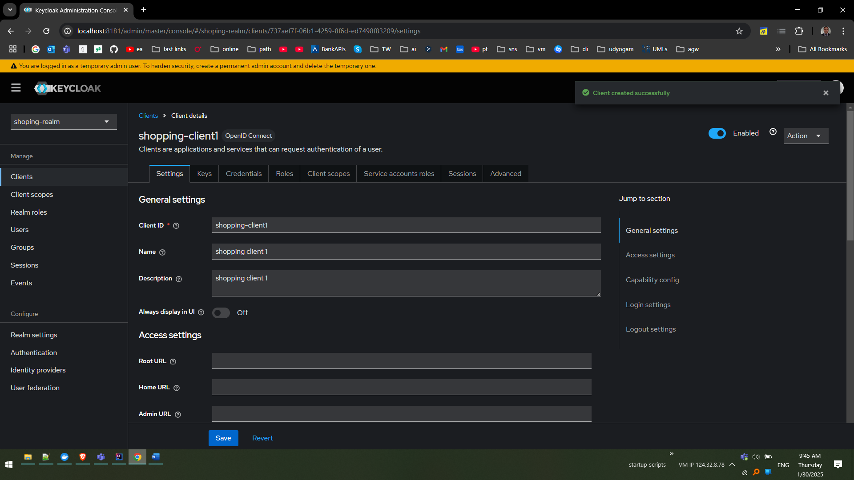

Navigate to ‘credentials’ tab and pick the credentials

KA1TvT76ojagwUqbJazPSs9YnQpwMs2j

Navigate to Realm Settings and click on the OpenId Endpoint Configuration to copy the issuer details

Notice the highlighted endpoint, this will be used in the spring boot application

Issuer: <http://localhost:8181/realms/shoping-realm>

Accessing Eureka Web securely

Notice when we try to access the discovery server via secured apigatway it throws error 401 as well

Add Security Configuration to the discovery service as below

Below is the securityconfiguration

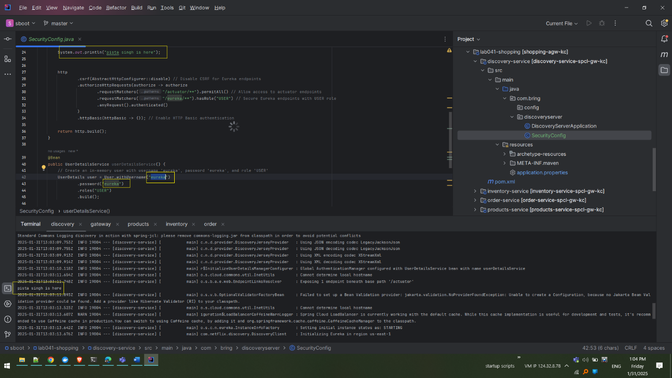

Below is the pom.xml

